**Ideation Phase**

**Define the Problem Statements**

|  |  |
| --- | --- |
| Date | 27 Jun 2025 |
| Team ID | LTVIP2025TMID41259 |
| Project Name | Pattern Sense: Classifying Fabric Patterns using Deep Learning |
| Maximum Marks | 2 Marks |

**Customer Problem Statement Template:**

In the textile and fashion industries, identifying and categorizing fabric patterns (e.g., floral, striped, polka dot, geometric) is essential for inventory management, design cataloguing, quality control, and customer recommendation systems. Traditionally, this task relies on manual inspection, which is time-consuming, subjective, and prone to inconsistency.

With the growth of digital fashion platforms and large-scale textile production, there is a pressing need for an automated, scalable, and accurate method to classify fabric patterns from images.

Reference: <https://miro.com/templates/customer-problem-statement/>

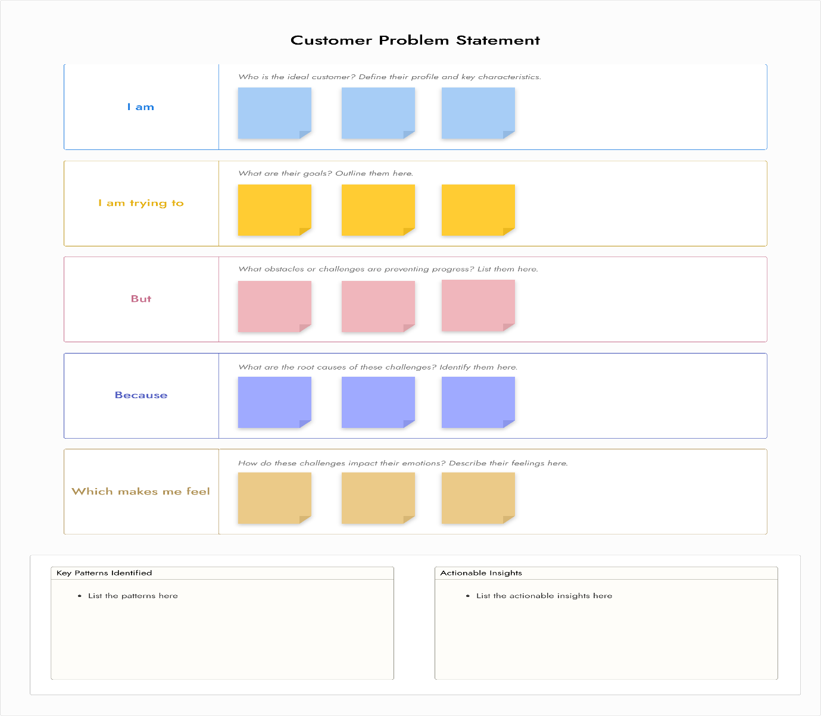

|  |  |  |  |  |  |
| --- | --- | --- | --- | --- | --- |
| **Problem Statement (PS)** | **I am (Customer)** | **I’m trying to** | **But** | **Because** | **Which makes me feel** |
| PS-1 | A college student | Organize my study schedule | I have too many classes and assignments | It’s difficult to keep track of everything | Overwhelmed and stressed |
| PS-2 | A college student | Use my free time productively | I don’t know how to plan my breaks | I feel guilty wasting time and can’t relax | Anxious and frustrated |